https://stuertz.com/messen/fensterbau-frontale/

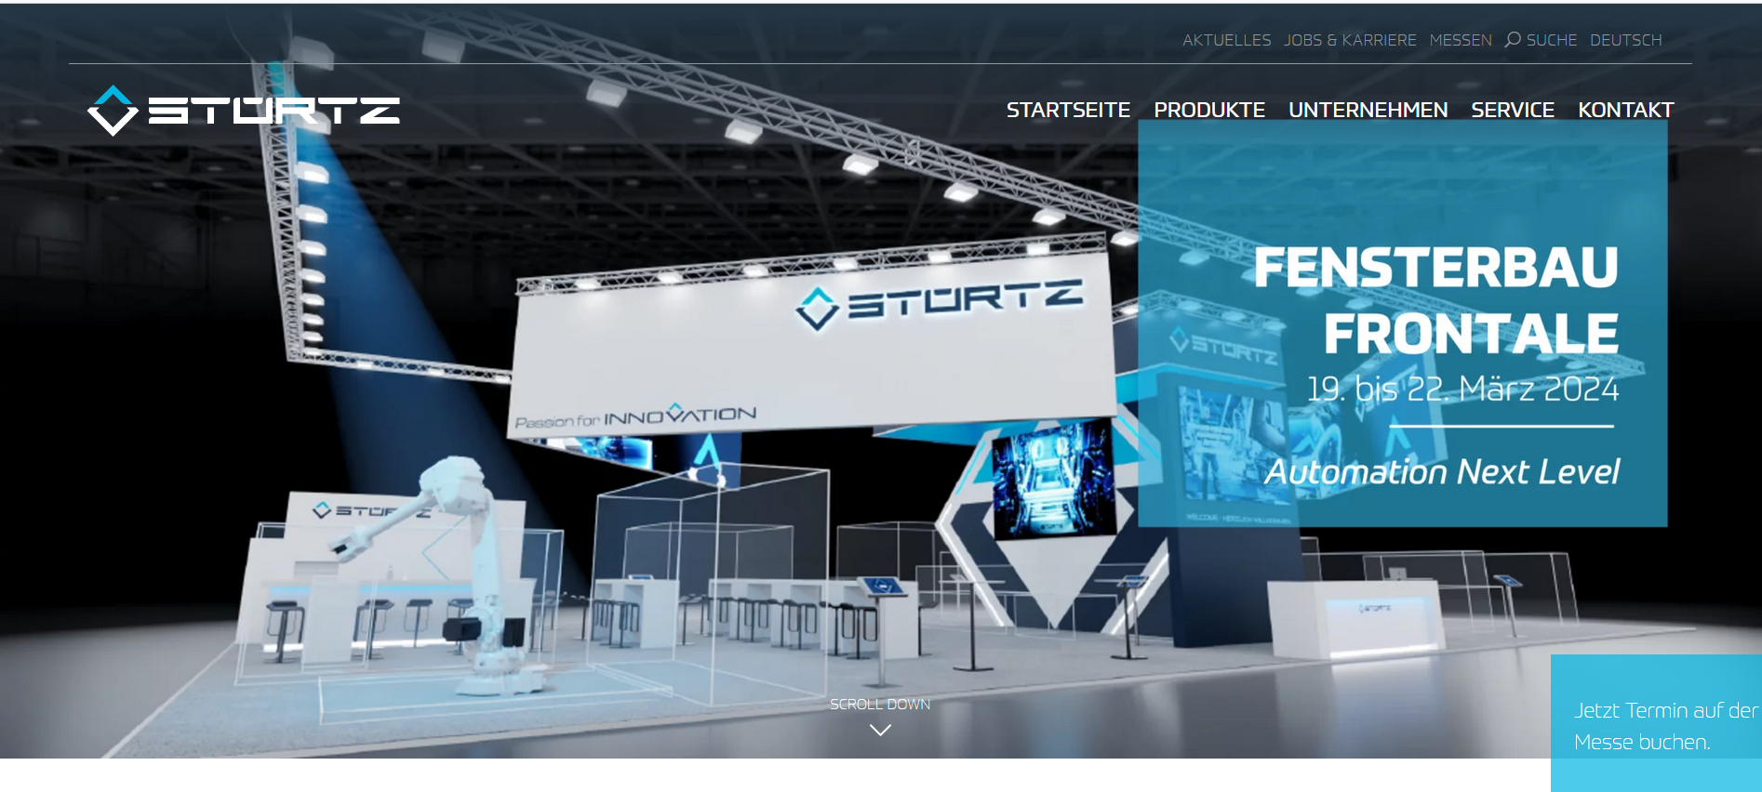
Booking-Tool: https://outlook.office365.com/book/StrtzFensterbauFrontalePL@stuertz.com/

